Name: Deep Vaviya
Class:TY-4
Roll no: 72
PRN:124BTCM2011
Batch C

Experiment No - 03

Title: Implement Storage as a Service using AWS

Learning Outcome: Configure cloud-based storage solutions by implementing Storage as a Service

Theory:
Storage as a Service(SAAS) is a cloud computing model that provides users with a platform to store and access data over the internet. Instead of maintaining physical storage devices, users rent storage capacity from cloud providers like AWS, Azure, or Google Cloud on a pay-as-you-go basis.This model provides flexibility, scalability, and data durability, making it ideal for individuals, startups, and enterprises alike.

Amazon S3 is an object storage service that stores data as objects within buckets. An object consists of the data itself, a key (unique identifier), and metadata. Buckets act as containers for storing these objects.

Key Features of Amazon S3:
- Durability: 99.999999999% durability (11 9’s).
- Scalability: Automatically scales to handle growing storage needs.
- Security: Integrated with AWS IAM, supports encryption (both at rest and in transit).
- Versioning: Maintains multiple versions of an object.
- Storage Classes: Supports different classes such as Standard, Intelligent-Tiering, Glacier (for archival), etc.
- Lifecycle Policies: Automatically transitions data between storage classes or deletes them based on defined rules.

Applications of S3 (Storage as a Service):
One of its prominent uses is hosting static websites, allowing developers to store HTML, CSS, JavaScript, and media files that can be accessed directly over the internet. It is also widely used for storing backups and disaster recovery data, ensuring data durability and availability in case of system failures. Another key application is in building data lakes for analytics and AI/ML, where massive volumes of structured and unstructured data are stored for processing and insights. Additionally, S3 serves as a reliable platform for media and content storage and delivery, supporting streaming services and file distribution. Lastly, it plays a crucial role in logging and monitoring, where log files from various systems and applications are securely stored for audit, analysis, and troubleshooting purposes.

Procedure:
Step 01:Create a bucket and Enable the static website hosting
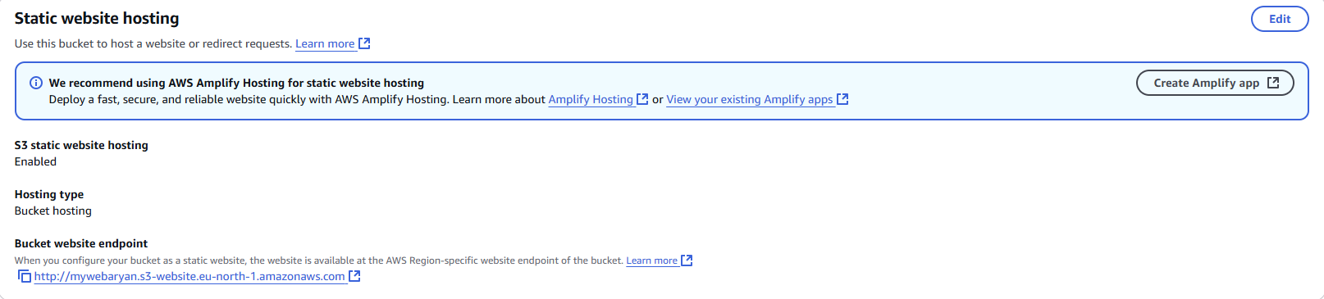
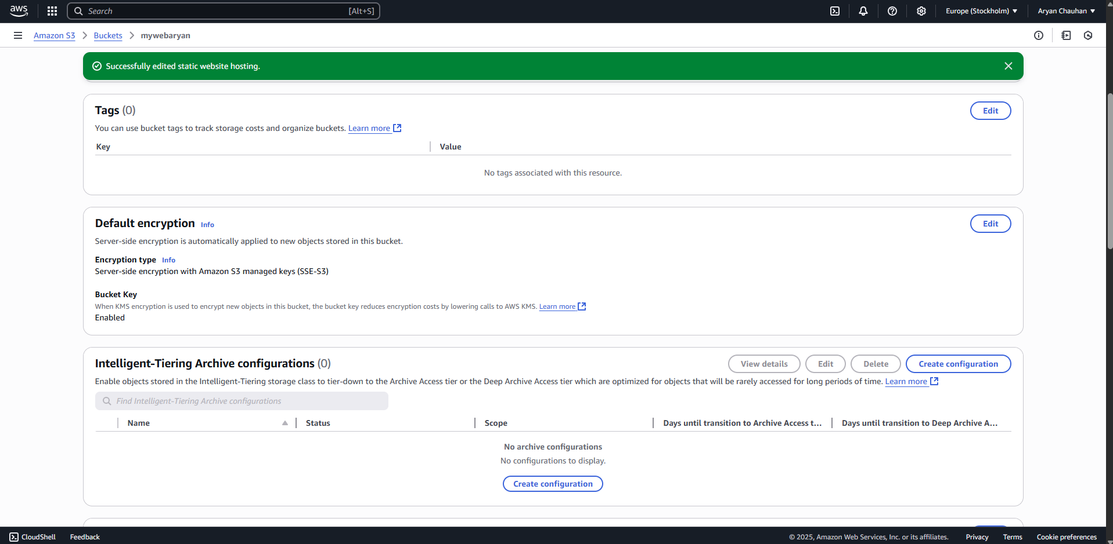

Step 02:Open the permission tab and uncheck the Block all public access
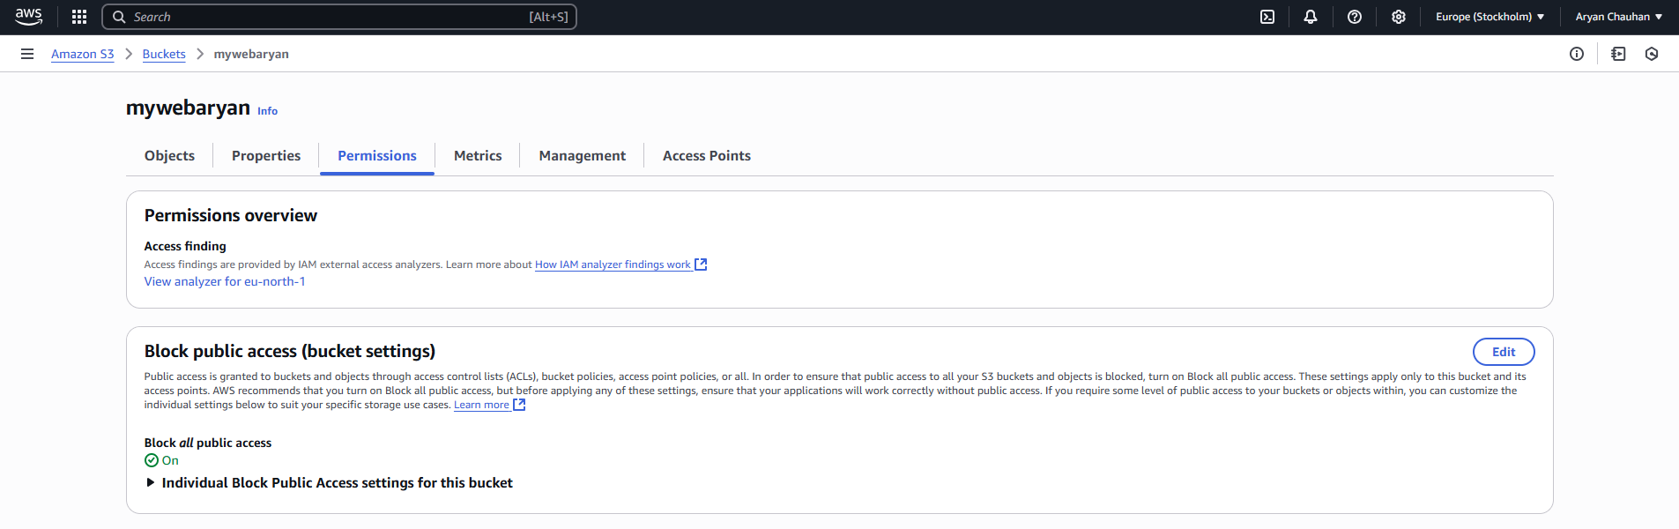
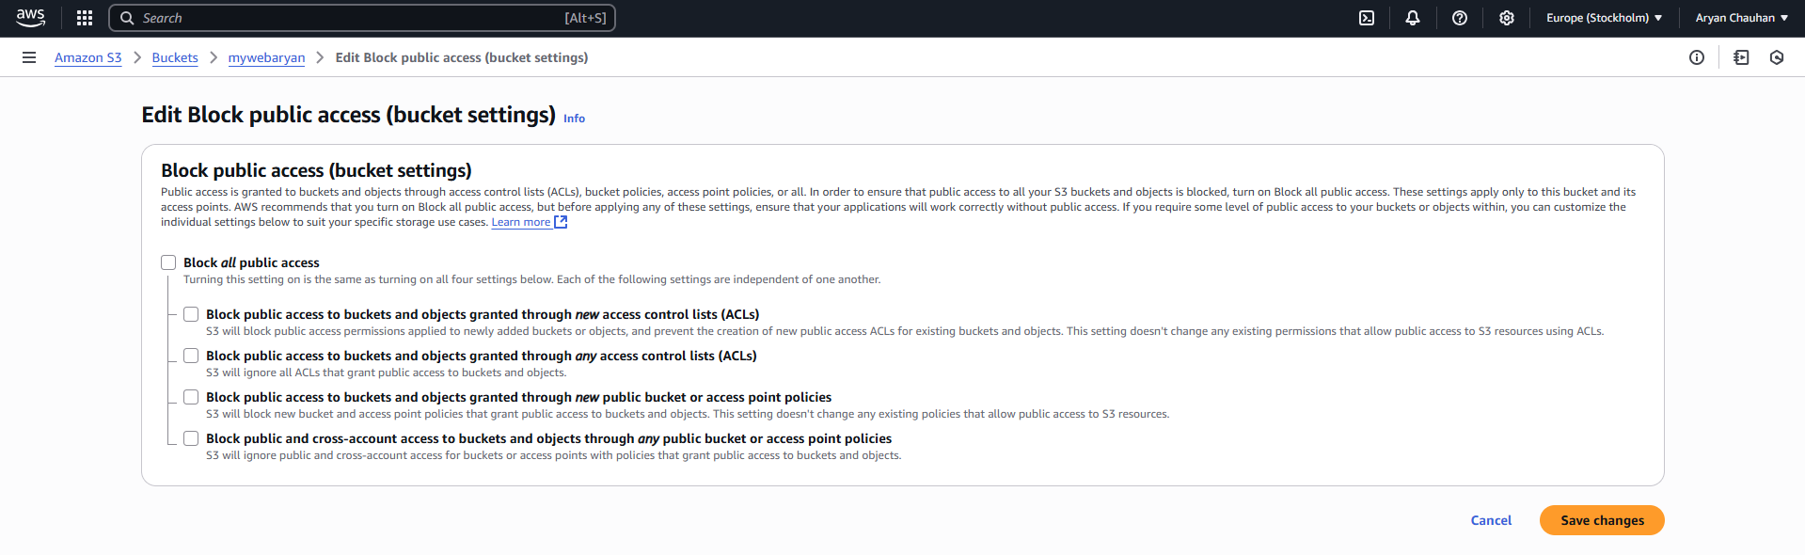
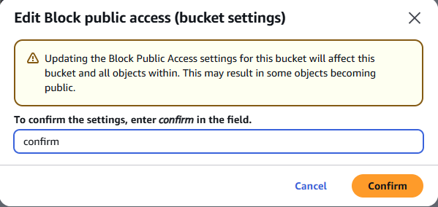

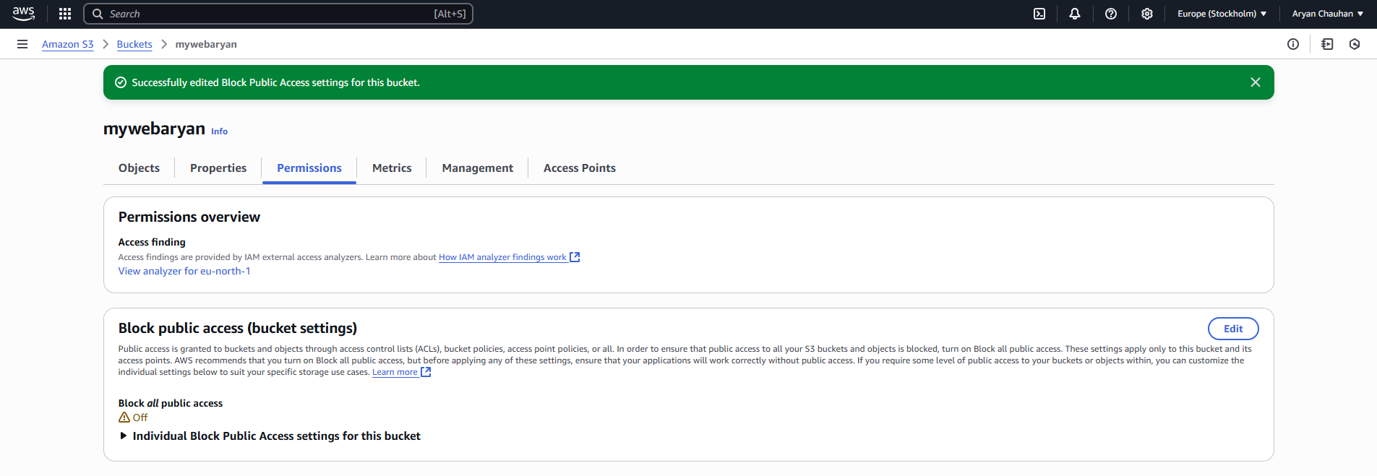
Step 03:Edit bucket policy
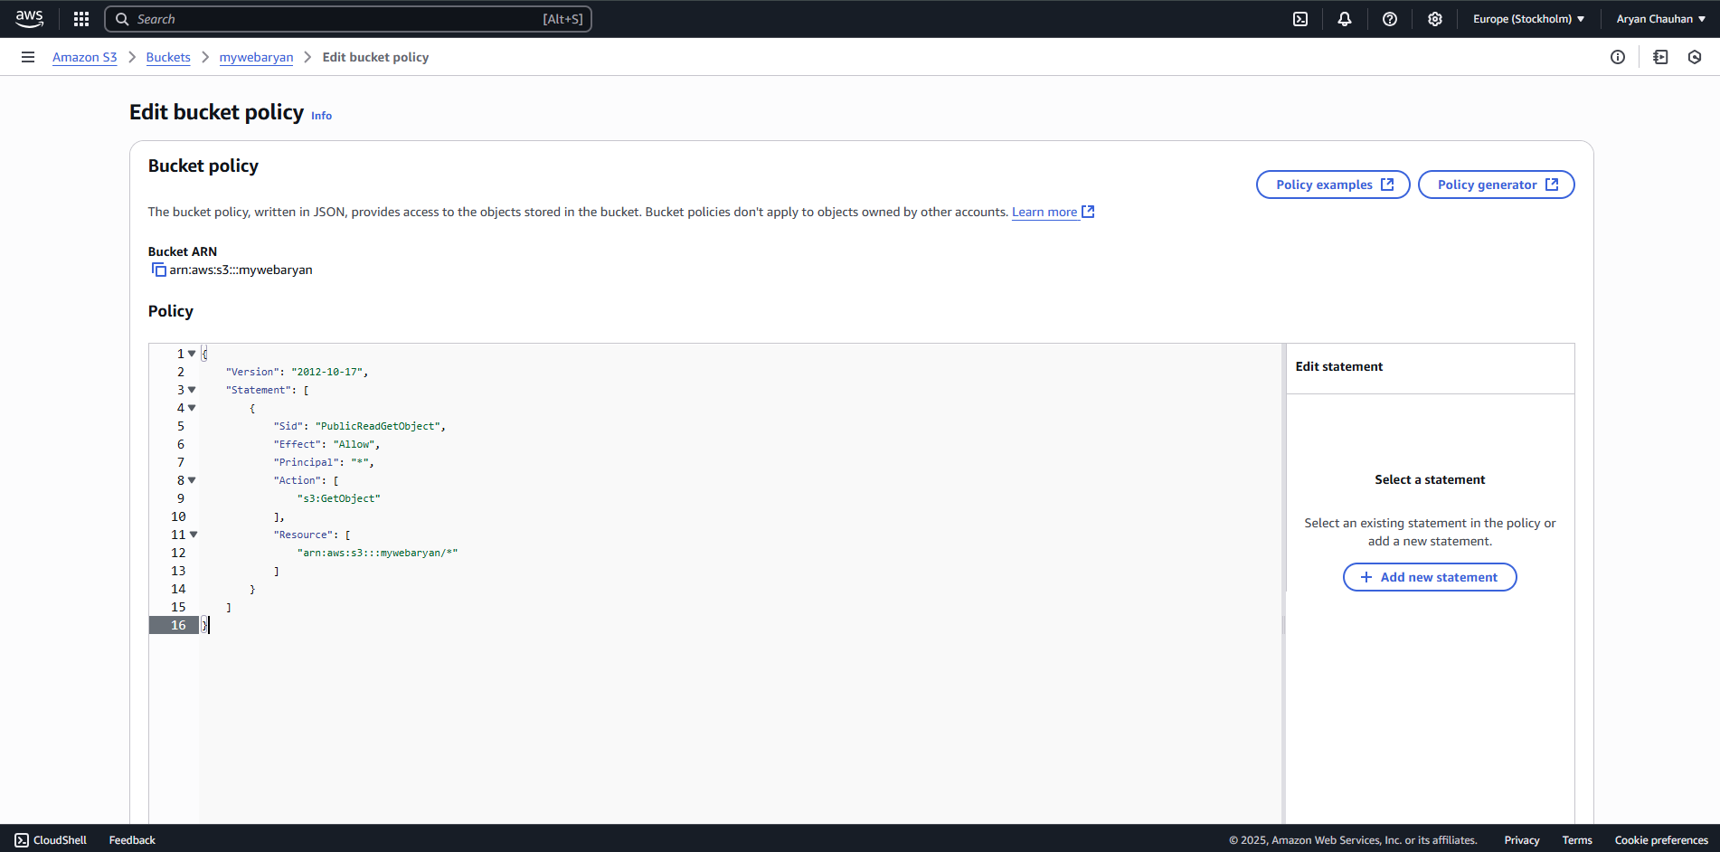

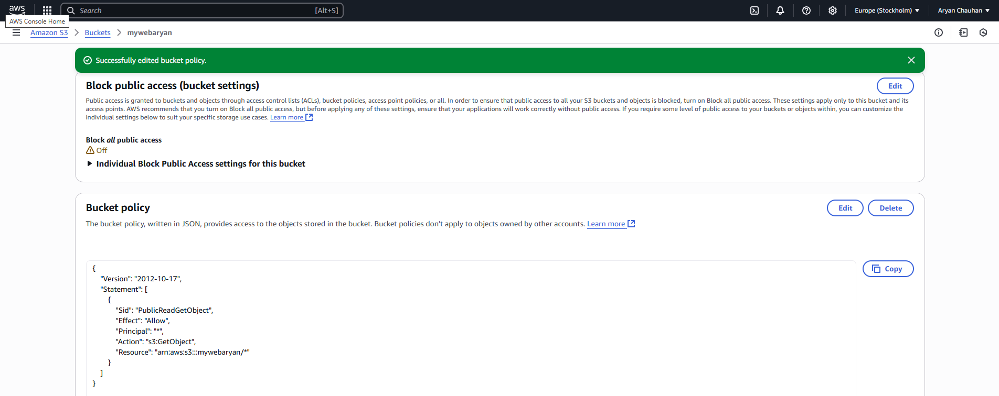

Step 04:Upload the index.html file
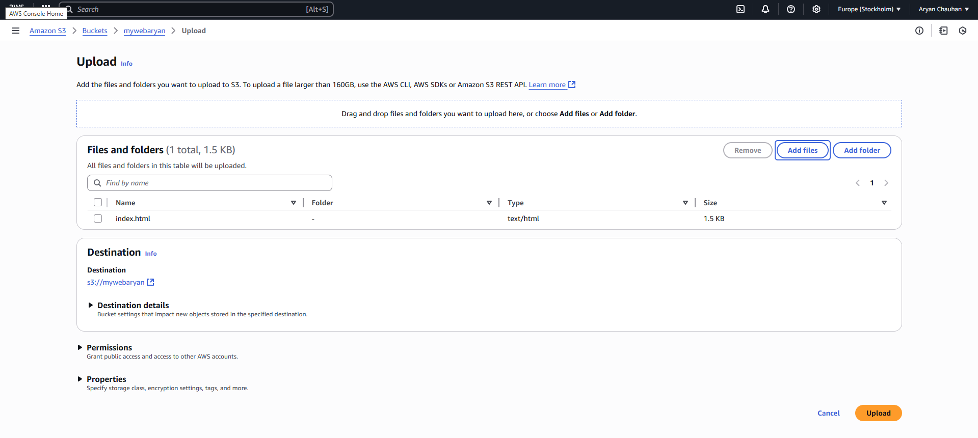

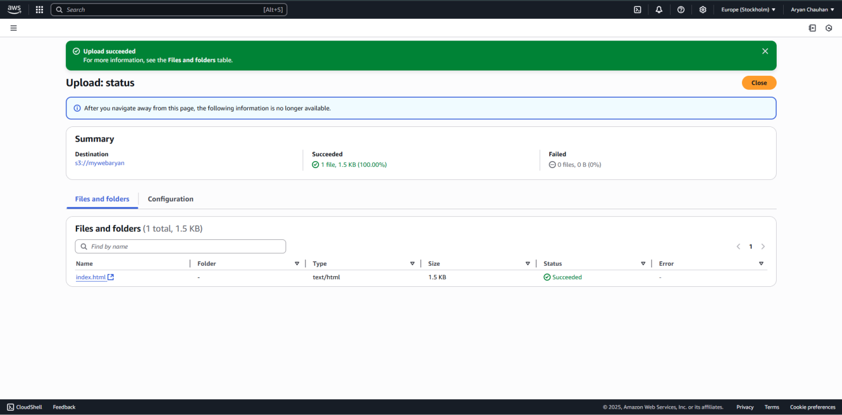

Step 05:The final Webpage
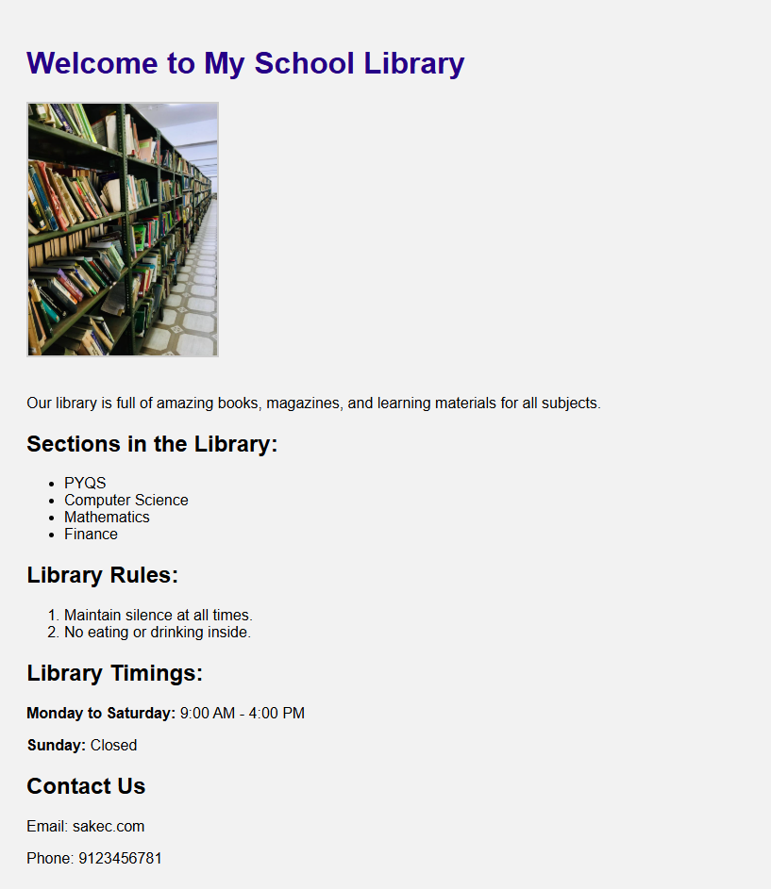

Step 06:Delete the entire bucket
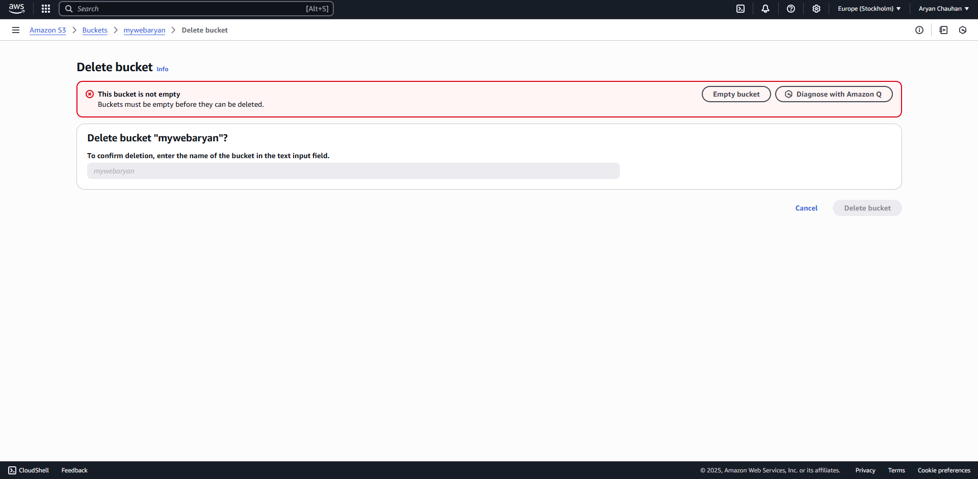

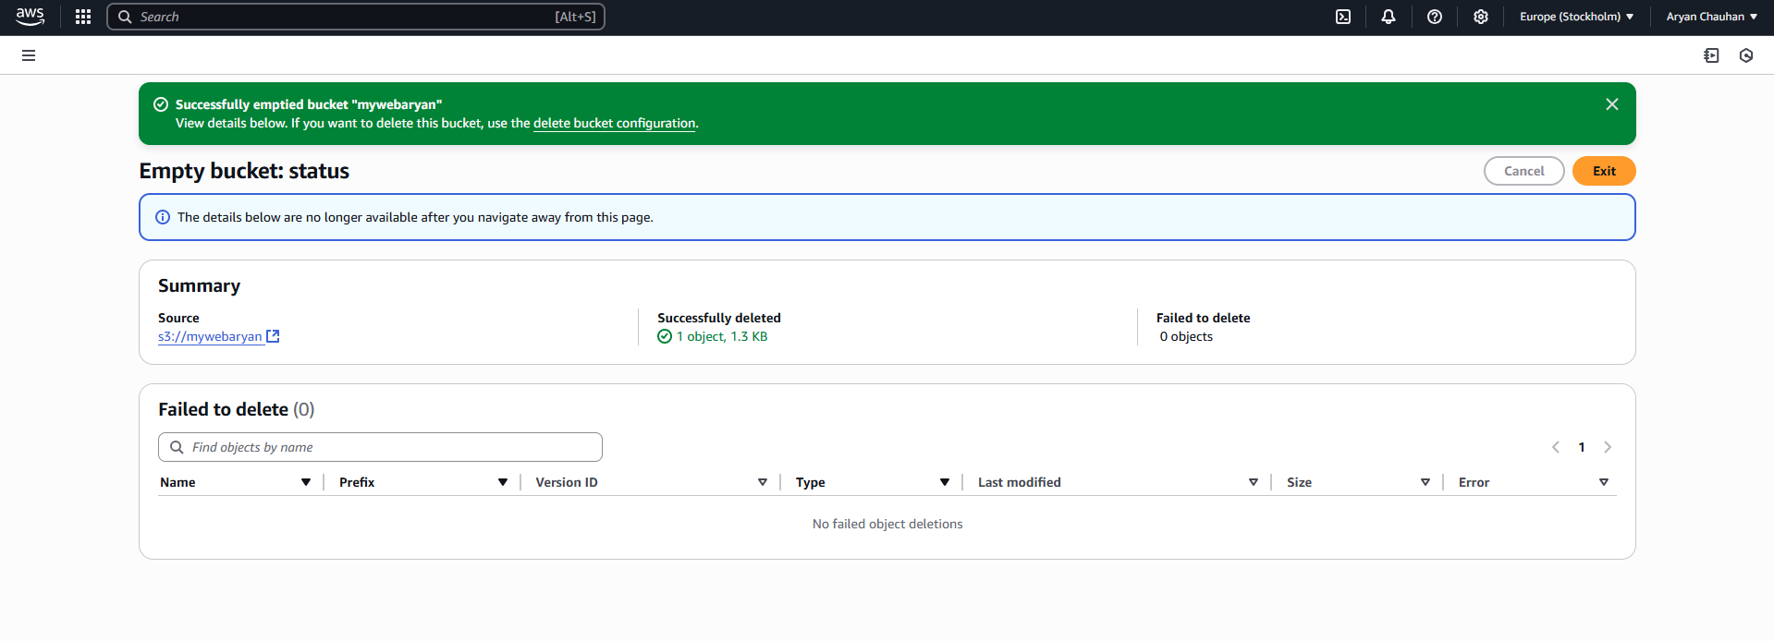

Conclusion:
We successfully implemented Storage as a Service using AWS S3. The core objective was to understand and apply cloud-based storage solutions using Amazon's Simple Storage Service (S3). Starting with logging into the AWS Management Console and creating a new S3 bucket with appropriate configurations such as bucket name, region, and access permission . We used an index.html file as the main entry point for the website. We uploaded this HTML file to the S3 bucket and configured the bucket settings to enable static website hosting. We also set the index.html file as the default document so that users could access the webpage directly via the S3-generated website url.This experiment enhanced my practical understanding of AWS S3's capabilities, including object storage, permission settings, and static site hosting

